

**Assignment**

**Name: Abu Hurera**

**Roll No: 2k23/BLCS/05**

**Class: 1st Year**

**Subject: Object Oriented Programming(OOP)**

**Q.No.1. Write a program to print the first 30 odd and even numbers, also display sum of all even and odd numbers separately. (By using Loop)**

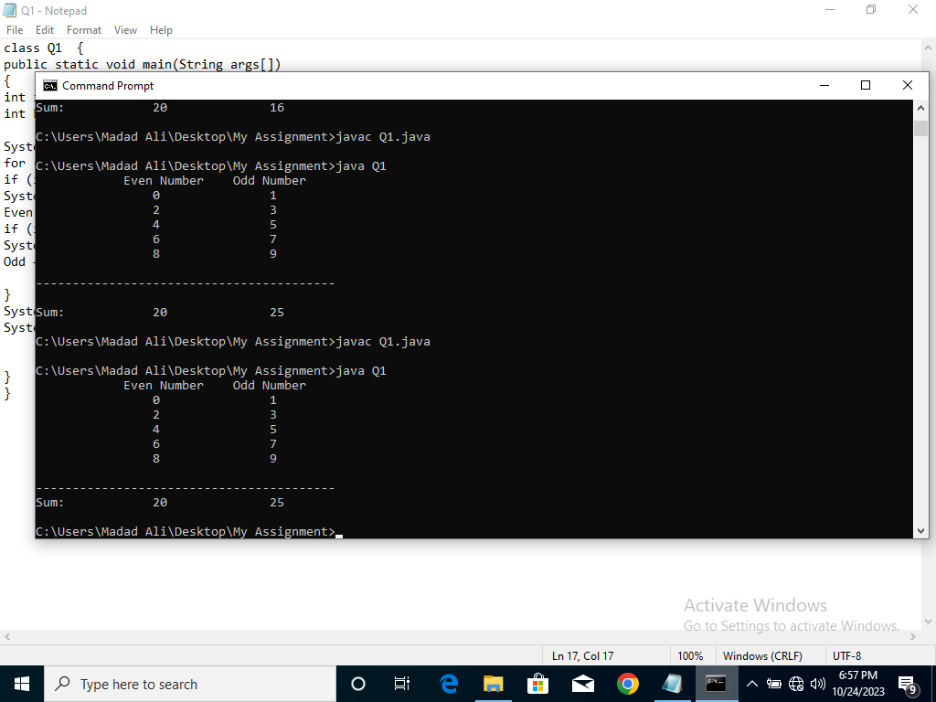**Ans: Output:**

class Q1 {

public static void main(String args[])

{

int i;

int Even=0,Odd=0;

System.out.println("\t Even Number\t Odd Number");

for (i=0;i<=9;i++) {

if (i%2==0){

System.out.print("\t\t"+i);

Even += i; }

if (i%2==1) {

System.out.print("\t\t"+i+"\n");

Odd +=i; }

}

System.out.print("\n-----------------------------------------");

System.out.println("\nSum:\t\t"+Even+"\t\t"+Odd);

}

}

**Q.No.2. Write a program that asks the user to enter Basic pay and print pay-slip of the Employee.**

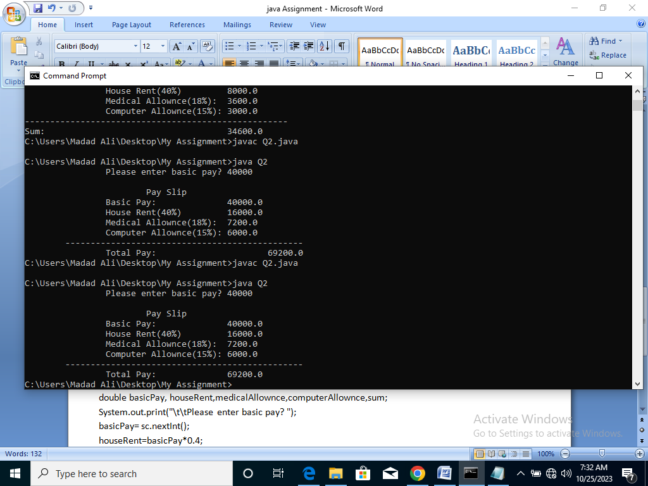**Ans:** **Output:**

import java.util.Scanner;

class Q2 {

public static void main(String args[])

{

Scanner sc=new Scanner(System.in);

double basicPay, houseRent,medicalAllownce,computerAllownce,sum;

System.out.print("\t\tPlease enter basic pay? ");

basicPay= sc.nextInt();

houseRent=basicPay*0.4;

medicalAllownce=basicPay*0.18;

computerAllownce=basicPay*0.15;

sum=basicPay+houseRent+medicalAllownce+computerAllownce;

System.out.println("\n\t\t\tPay Slip");

System.out.println("\t\tBasic Pay:\t\t"+basicPay);

System.out.println("\t\tHouse Rent(40%)\t\t"+houseRent);

System.out.println("\t\tMedical Allownce(18%):\t"+medicalAllownce);

System.out.println("\t\tComputer Allownce(15%):\t"+computerAllownce);

System.out.println("\t-----------------------------------------------");

System.out.print("\t\tTotal Pay:\t\t"+sum);

}

}

**Q.No.3. Write a program to print the following series. (By using Loop)**

**Ans: Output:**

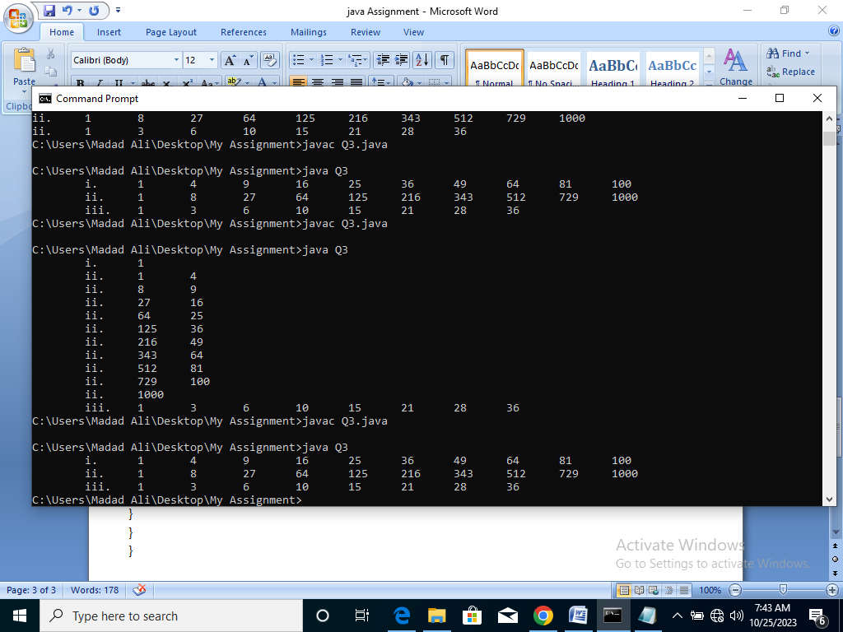 class Q3 {

public static void main(String args[]) {

int a;

System.out.print("\ti.\t");

for(a=1;a<=10;a++) {

System.out.print(a*a+"\t");

}

System.out.print("\n\tii.\t");

for(a=1;a<=10;a++) {

System.out.print(a*a*a+"\t");

}

System.out.print("\n\tiii.\t");

int n=1;

for(a=1;a<=8;a++) {

System.out.print(n+"\t");

n += (a+1);

}

}

}

**Q.No.4. Write a program to calculate area of square.**

**Ans: Output:**

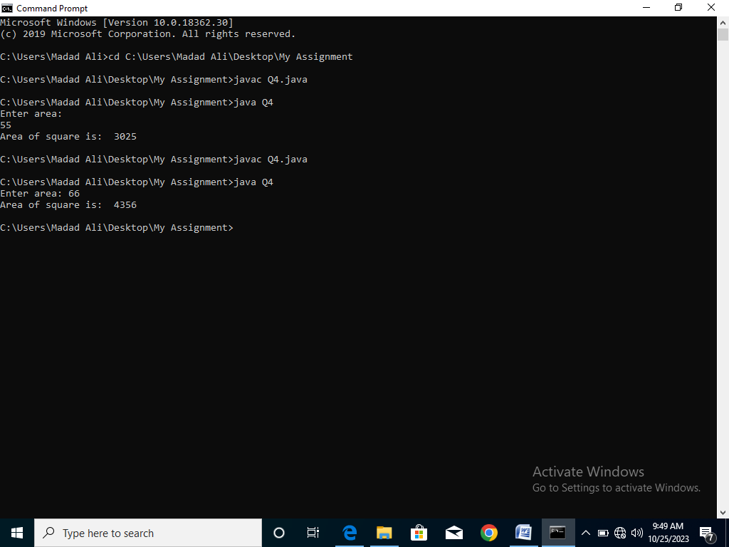import java.util.Scanner;

class Q4 {

public static void main(String args[])

{

int area;

Scanner sc=new Scanner(System.in);

System.out.print("Enter area: ");

area= sc.nextInt();

System.out.println("Area of square is: "+area*area);

} }

**Q.No.5. Write a program to calculate area of rectangle.**

**Ans: Output:**

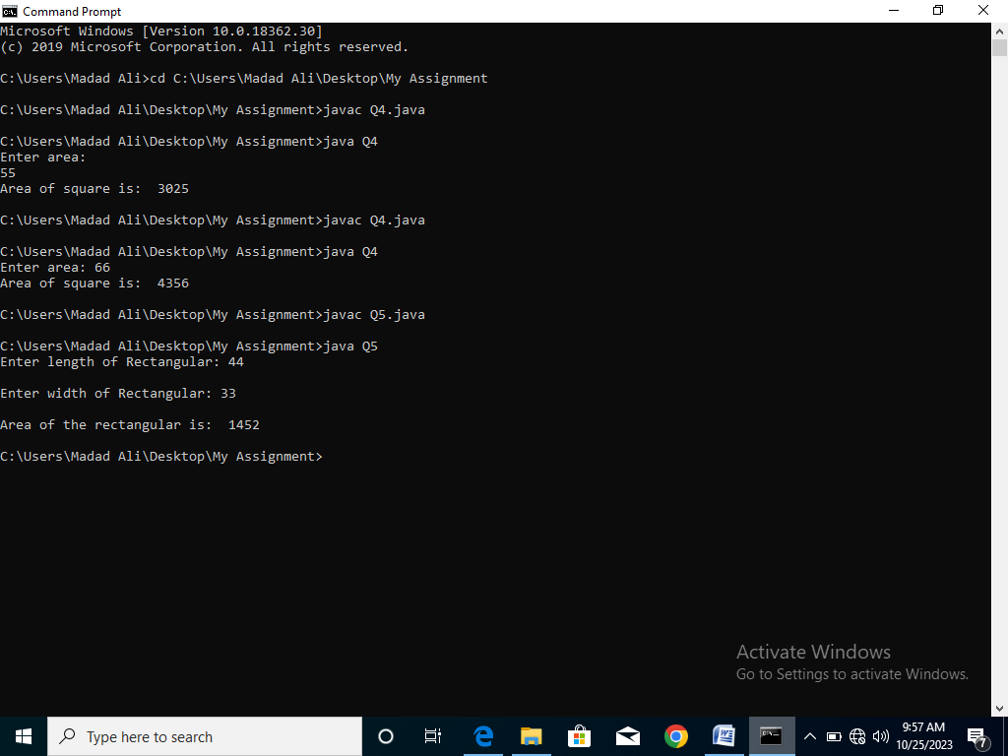import java.util.Scanner;

class Q5 {

public static void main(String args[])

{

Scanner sc=new Scanner(System.in);

int length,width;

System.out.print("Enter length of Rectangular: ");

length= sc.nextInt();

System.out.print("\nEnter width of Rectangular: ");

width= sc.nextInt();

System.out.println("\nArea of the rectangular is: "+length*width);

}

}**Q.No.6. Write a program to convert a given amount in notes/coins?**

**Ans: Output:**

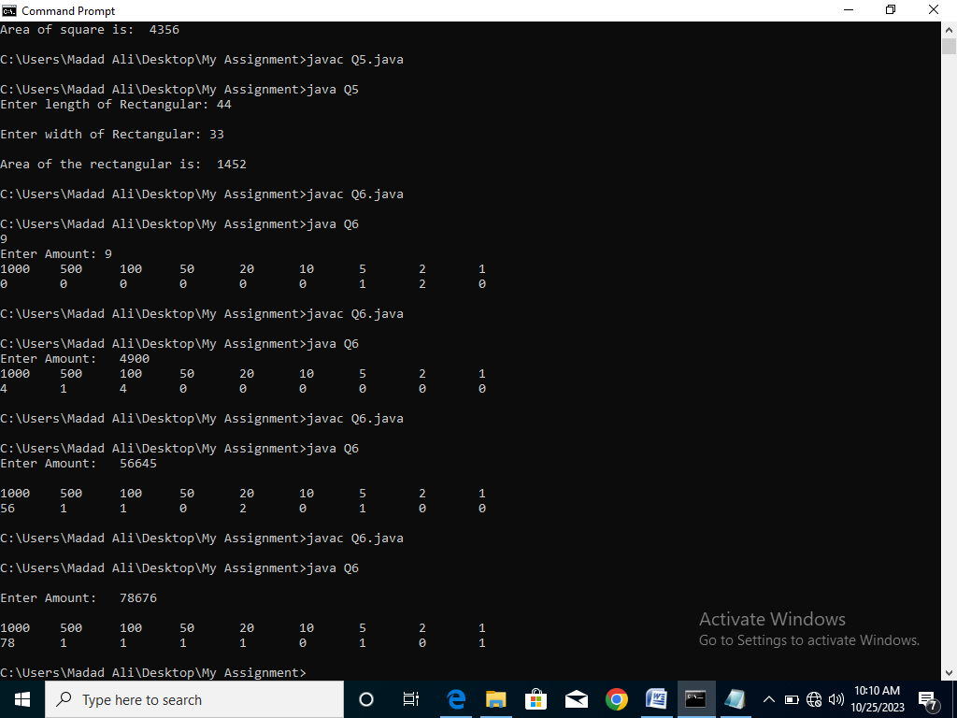import java.util.Scanner;

class Q6 {

public static void main(String args[])

{

Scanner sc=new Scanner(System.in);

System.out.print("\nEnter Amount: ");

int amount= sc.nextInt();

int note1=amount/1000;

amount=amount%1000;

int note2=amount/500;

amount=amount%500;

int note3=amount/100;

amount=amount%100;

int note4=amount/50;

amount=amount%50;

int note5=amount/20;

amount=amount%20;

int note6=amount/10;

amount=amount%10;

int note7=amount/5;

amount=amount%5;

int note8=amount/2;

amount=amount%2;

int note9=amount/1;

System.out.println("\n1000\t500\t100\t50\t20\t10\t5\t2\t1");

System.out.println(note1+"\t"+note2+"\t"+note3+"\t"+note4+"\t"+note5+"\t"+note6+"\t"+note7+"\t"+note8+"\t"+note9+"\t"); }

}

**Q.No.7. Write a program to take input of Seat No, Subjects & Marks of a student & calculate the total & percentage, & display the output in table format.**

**Ans: Output:**

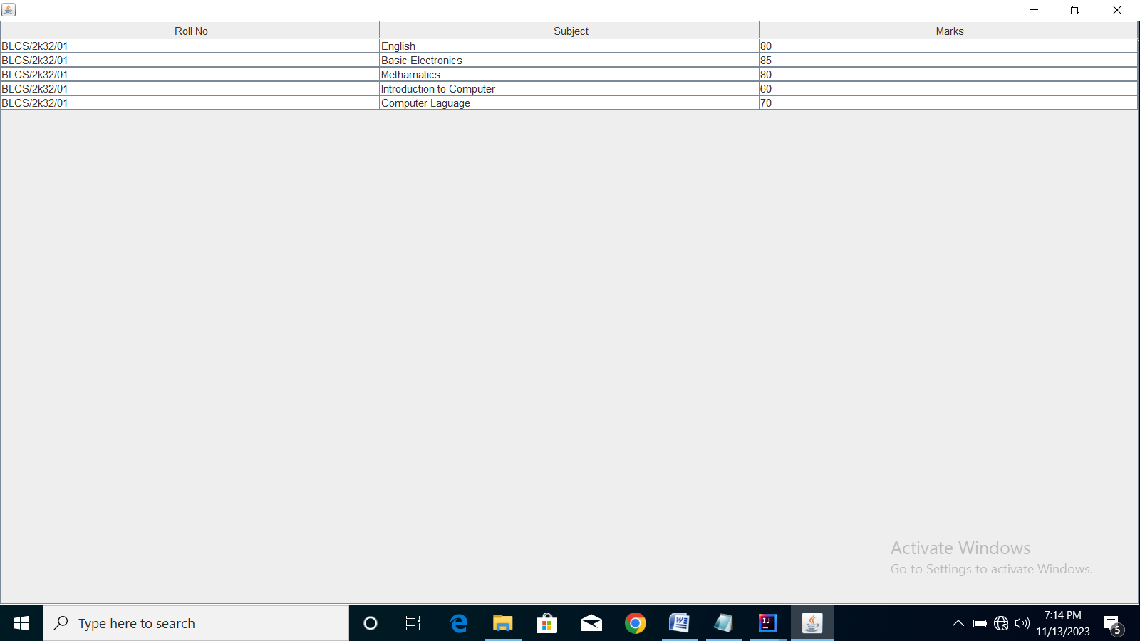import javax.swing.JFrame;

import javax.swing.JTable;

import javax.swing.JScrollPane;

import javax.swing.table.DefaultTableModel;

import java.util.Scanner;

class Q7 {

public static void main(String args[]){

new MyTable();

}

}

class MyTable extends JFrame {

JTable table;

MyTable() {

setSize(500,300);

setDefaultCloseOperation(EXIT_ON_CLOSE);

setVisible(true);

Object [][] data={{"BLCS/2k32/01","English",80},{"BLCS/2k32/01","Basic Electronics",85},{"BLCS/2k32/01","Methamatics",80},{"BLCS/2k32/01","Introduction to Computer",60},{"BLCS/2k32/01","Computer Laguage",70}};

String [] columnNames={"Roll No","Subject","Marks"};

DefaultTableModel model= new DefaultTableModel(data,columnNames);

table = new JTable(model);

add (new JScrollPane(table));

}

}

**Q.No.8. Write a program to calculate area of circle.**

**Ans: Output:**

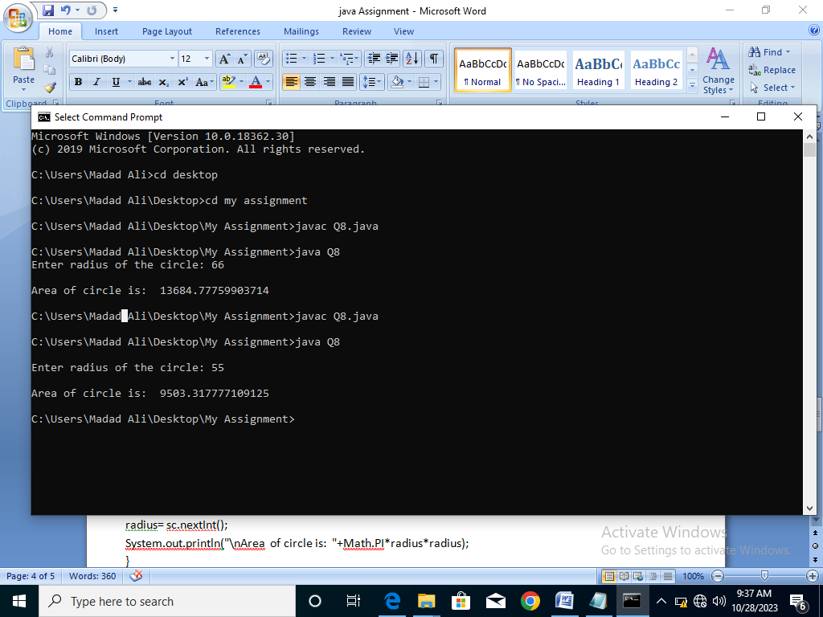 import java.util.Scanner;

class Q8 {

public static void main(String args[])

{

int area,radius;

Scanner sc=new Scanner(System.in);

System.out.print("\nEnter radius of the circle: ");

radius= sc.nextInt();

System.out.println("\nArea of circle is: "+Math.PI*radius*radius);

}

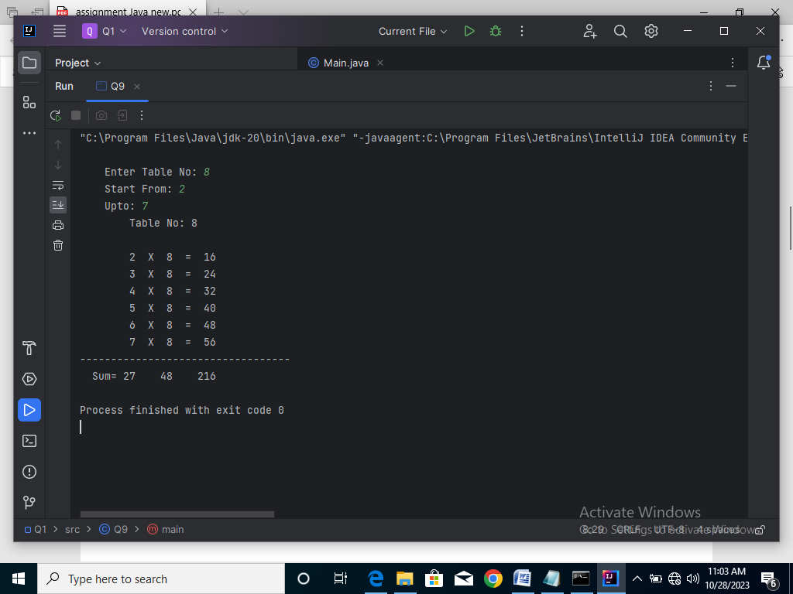**Q.No.9. Write a program to generate multiplication table. (By using Loop)  
Ans: Output:**

import java.util.Scanner;

class Q9 {

public static void main(String args[])

{

int sum1=0,sum2=0,sum3=0;

int tableNo,start,Upto;

Scanner sc=new Scanner(System.in);

System.out.print("\n\tEnter Table No: ");

tableNo= sc.nextInt();

System.out.print("\tStart From: ");

start= sc.nextInt();

System.out.print("\tUpto: ");

Upto= sc.nextInt();

System.out.println("\t\tTable No: "+tableNo);

System.out.println(" \t");

for(;start<=Upto;start++) {

System.out.println("\t\t"+start+" X "+tableNo+" = "+start*tableNo);

sum1=start+sum1;

sum2=tableNo+sum2;

sum3=+start*tableNo+sum3;

}

System.out.println("----------------------------------");

System.out.println(" " +Sum= "+sum1+" "+sum2+" "+sum3);

}

}

**Q.No.10. Write a program to convert a given Seconds into Hours, Minutes and Seconds?**

**Ans: Output:**

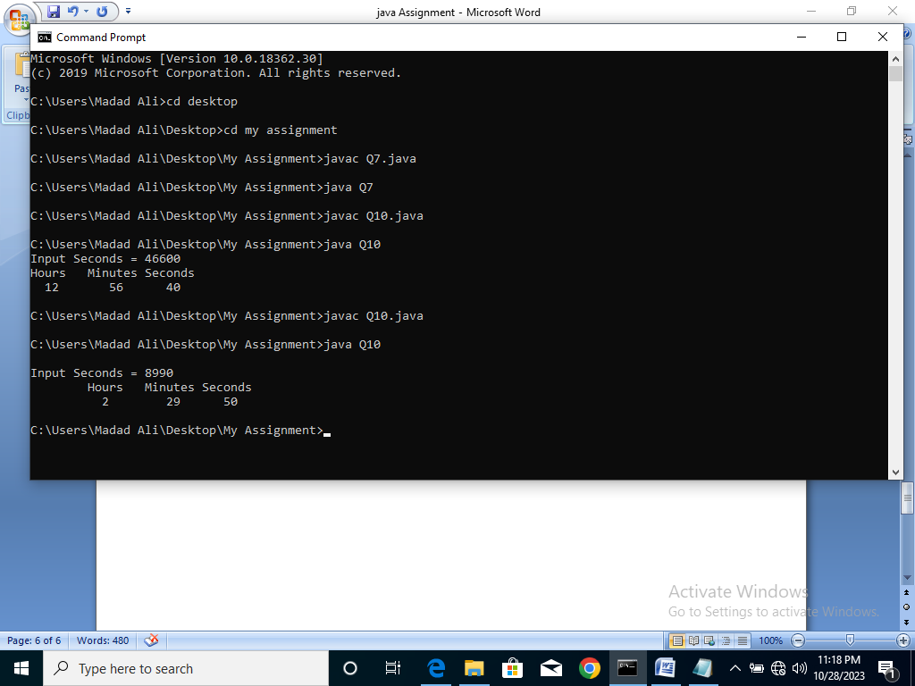import java.util.Scanner;

class Q10 {

public static void main(String args[])

{

int second,minutes,hour;

Scanner sc=new Scanner(System.in);

System.out.print("\nInput Seconds = ");

second= sc.nextInt();

hour=second/3600;

minutes=(second%3600)/60;

int seconds=second%60;

System.out.println("\tHours\tMinutes\tSeconds");

System.out.println("\t "+hour+"\t "+minutes+"\t "+seconds);

}

}

**Q.No.11. Write a Program to find the largest and smallest number from given 10 numbers.**

**Ans: Output:**

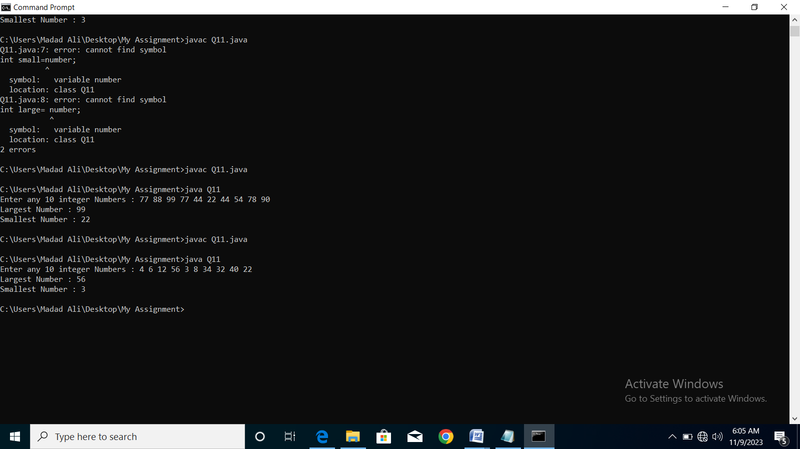import java.util.Scanner;

class Q11{

public static void main(String[] args) {

Scanner sc = new Scanner(System.in);

System.out.print("Enter any 10 integer Numbers : ");

int number= sc.nextInt();

int small=number;

int large= number;

for (int i=1; i<10; i++){

number= sc.nextInt();

if (number<small){

small= number;

}

if (number>large){

large= number;

}

}

System.out.println("Largest Number : "+large);

System.out.println("Smallest Number : "+small);

}

}

**Q.No.12. Write a program that asks the user to enter two numbers, and prints the sum, product, difference, quotient and remainder of the two numbers.**

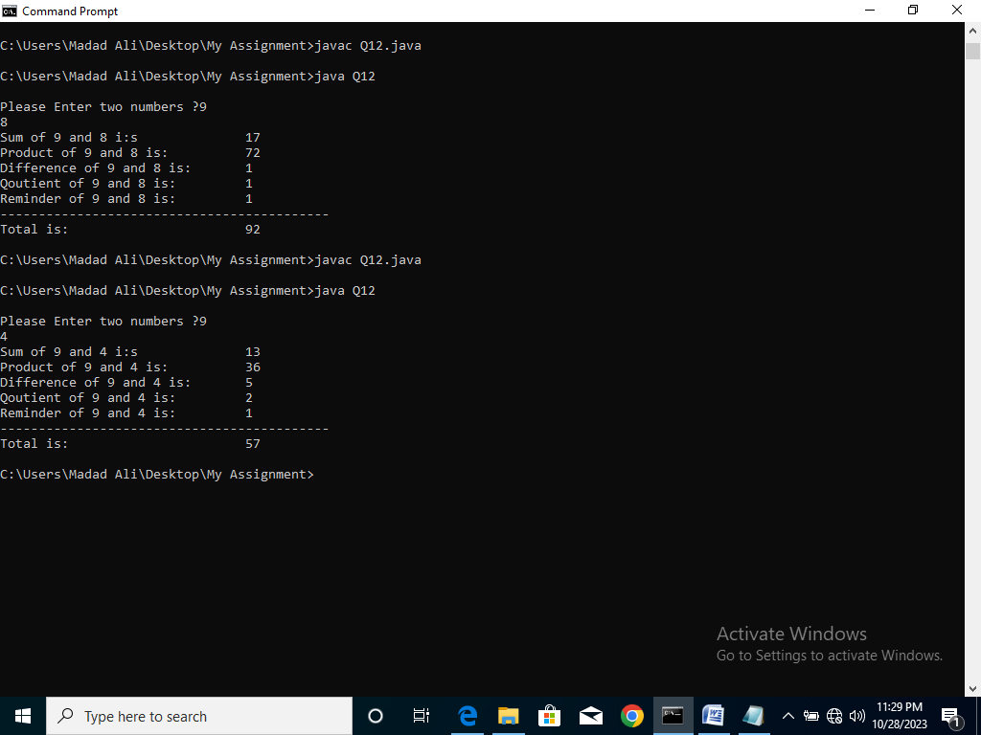**Ans: Output:**

import java.util.Scanner;

class Q12 {

public static void main(String args[])

{

Scanner input= new Scanner(System.in);

int number1,number2,addition,product,Difference,Qoutient,Reminder,Total;

System.out.print("\nPlease Enter two numbers ?");

number1= input.nextInt();

number2= input.nextInt();

addition=number1+number2;

product=number1*number2;

Difference=number1-number2;

Qoutient=number1/number2;

Reminder=number1%number2;

Total=addition+product+Difference+Qoutient+Reminder;

System.out.println("Sum of "+number1+" and "+number2+" i:s\t\t"+addition);

System.out.println("Product of "+number1+" and "+number2+" is:\t\t"+product);

System.out.println("Difference of "+number1+" and "+number2+" is:\t"+Difference);

System.out.println("Qoutient of "+number1+" and "+number2+" is:\t\t"+Qoutient);

System.out.println("Reminder of "+number1+" and "+number2+" is:\t\t"+Reminder);

System.out.println("-------------------------------------------");

System.out.println("Total is:\t\t\t"+Total);

} }

**Q.No.13. Write a program to convert binary number to octal number.**

**Ans: Output:**

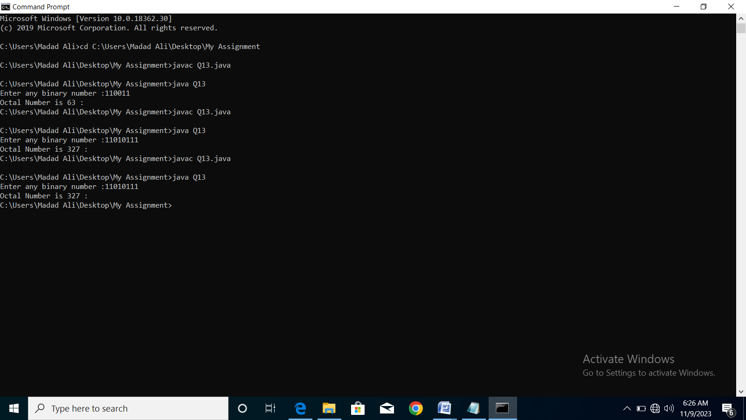import java.util.Scanner;

class Q13{

public static void main(String[] args) {

Scanner sc= new Scanner(System.in);

int reminder, octal=0, base=1;

System.out.print("Enter any binary number :");

int number = sc.nextInt();

while(number >0) {

reminder = number % 10;

octal = octal + reminder * base;

base = base * 2;

number = number / 10;

}

System.out.printf("Octal Number is %o : ",octal);

}

}

**Q.No.14. Write a program to display following output: (By using Loop)**

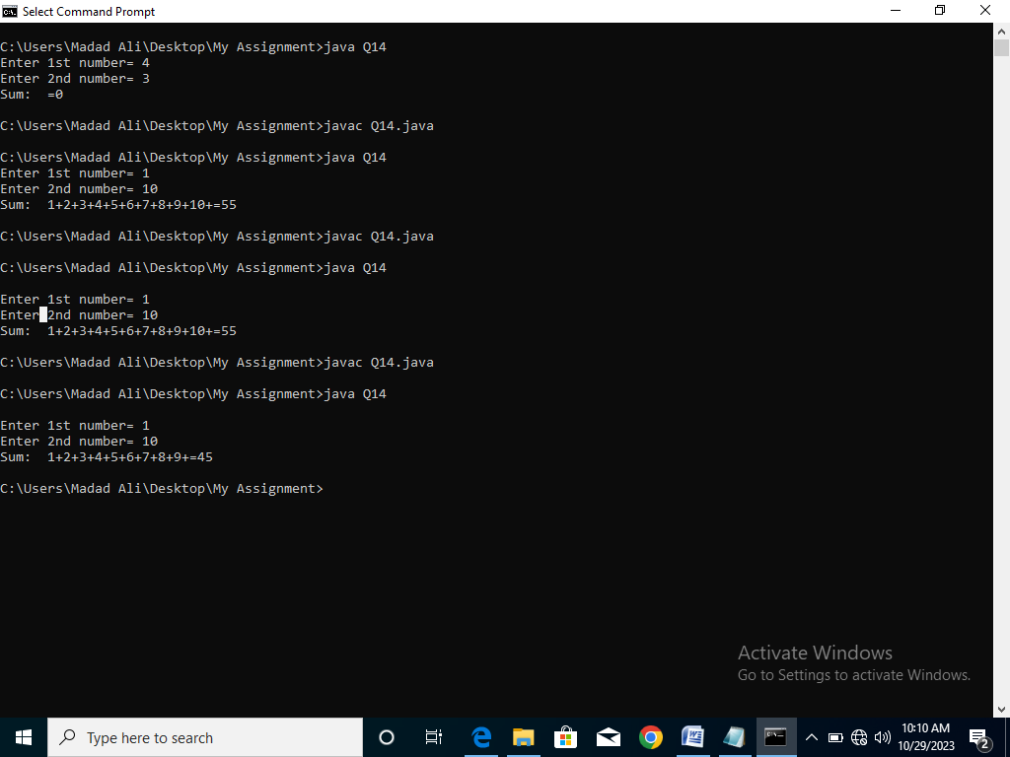**Ans:**  **Output:**

import java.util.Scanner;

class Q14 {

public static void main(String args[]) {

int no1,no2,sum=0;

Scanner sc=new Scanner(System.in);

System.out.print("\nEnter 1st number= ");

no1= sc.nextInt();

System.out.print("Enter 2nd number= ");

no2= sc.nextInt();

System.out.print("Sum: ");

for(;no1<=no2;no1++){

System.out.print(no1+"+");

sum=sum+no1; }

System.out.println("="+sum);

}

}

**Q.No.15. Write a program to convert a given number of Days in terms of Years, Weeks and Days.**

**Ans: Output:**

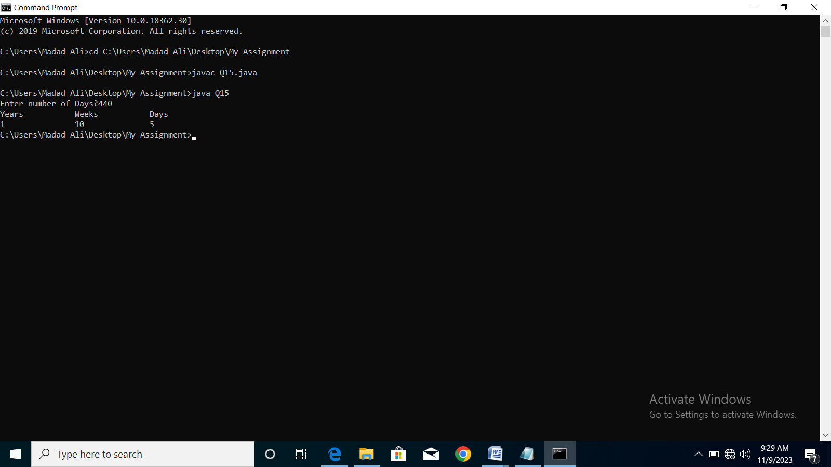import java.util.Scanner;

class Q15{

public static void main(String[] args) {

Scanner sc= new Scanner(System.in);

int days,year,week;

System.out.print("Enter number of Days?");

days= sc.nextInt();

year=days/365;

days=days%365;

week= days/7;

days=days%7;

System.out.println("Years\t\tWeeks\t\tDays");

System.out.printf(year+"\t\t"+week+"\t\t"+days);

}

}

**Q.No.16. Write a program that calculates the squares and cubes to print the output as under: (By using Loop)**

**Ans:**  **Output:**

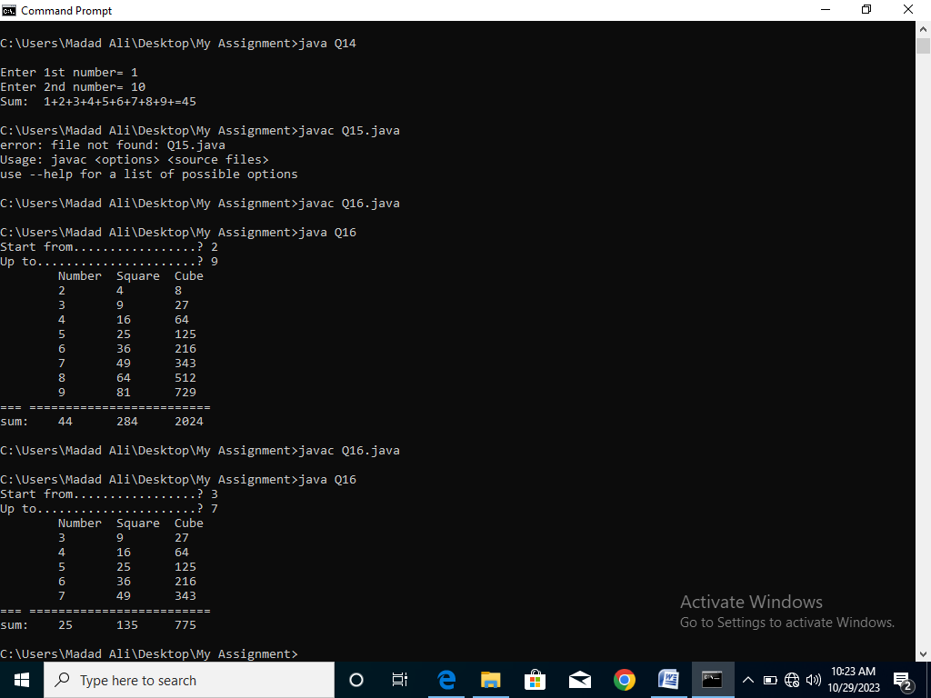import java.util.Scanner;

class Q16 {

public static void main(String args[])

{

int start,Upto,n=0,s=0,q=0;

Scanner sc=new Scanner(System.in);

System.out.print("Start from.................? ");

start= sc.nextInt();

System.out.print("Up to......................? ");

Upto= sc.nextInt();

System.out.println("\tNumber\tSquare\tCube");

for(;start<=Upto;start++) {

System.out.print("\t"+start+"\t"+start*start+"\t"+start*start*start+"\n");

n=start+n;

s=start*start+s;

q=start*start*start+q; }

System.out.println("=== =========================");

System.out.println("sum:\t"+n+"\t"+s+"\t"+q);

}

}

**Q.No.17. Write a program to find first Ten numbers Divisible by 5. (By using Loop)**

**Ans:** **Output:**

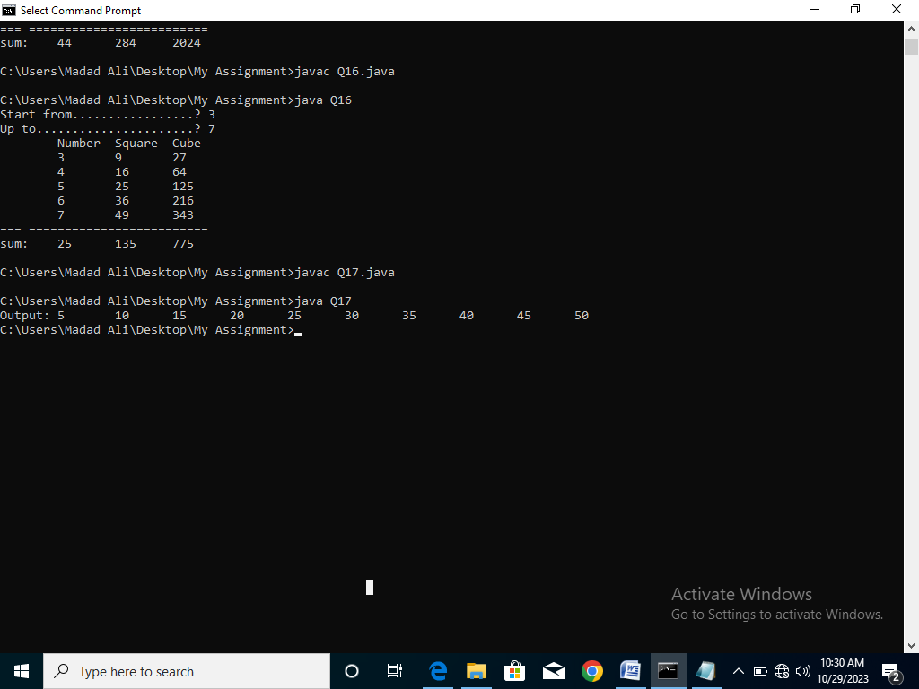class Q17 {

public static void main(String args[])

{

int a,b=5;

System.out.print("Output:\t");

for(a=1;a<=10;a++)

System.out.print(a*b+"\t");

}

}

**Q.No.18. Write a program to read two integers N1 and N2 and Swap their values.**

**Ans: Output:**

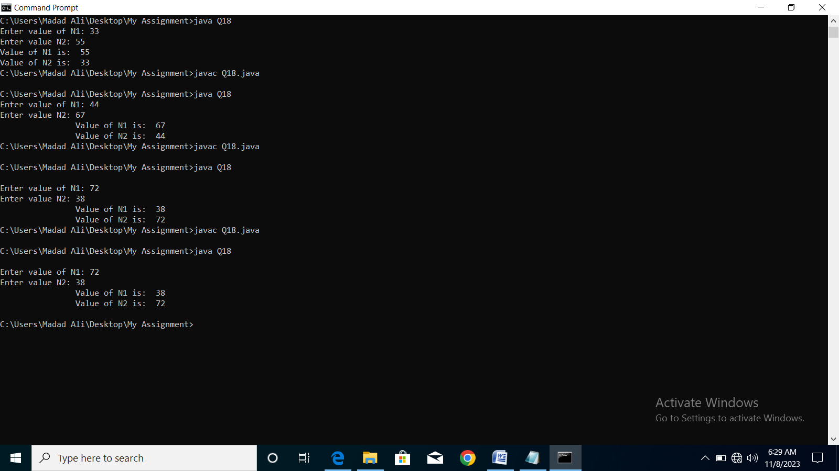import java.util.Scanner;

class Q18 {

public static void main(String args[])

{

int N1,N2,tam;

Scanner sc=new Scanner(System.in);

System.out.print("\nEnter value of N1: ");

N1= sc.nextInt();

System.out.print("Enter value N2: ");

N2= sc.nextInt();

tam=N1;

N1=N2;

N2=tam;

System.out.print("\t\tValue of N1 is: "+N1);

System.out.println("\n\t\tValue of N2 is: "+N2);

}

}

**Q.No.19. Write a program to convert decimal number into binary number?**

**Ans: Output:**

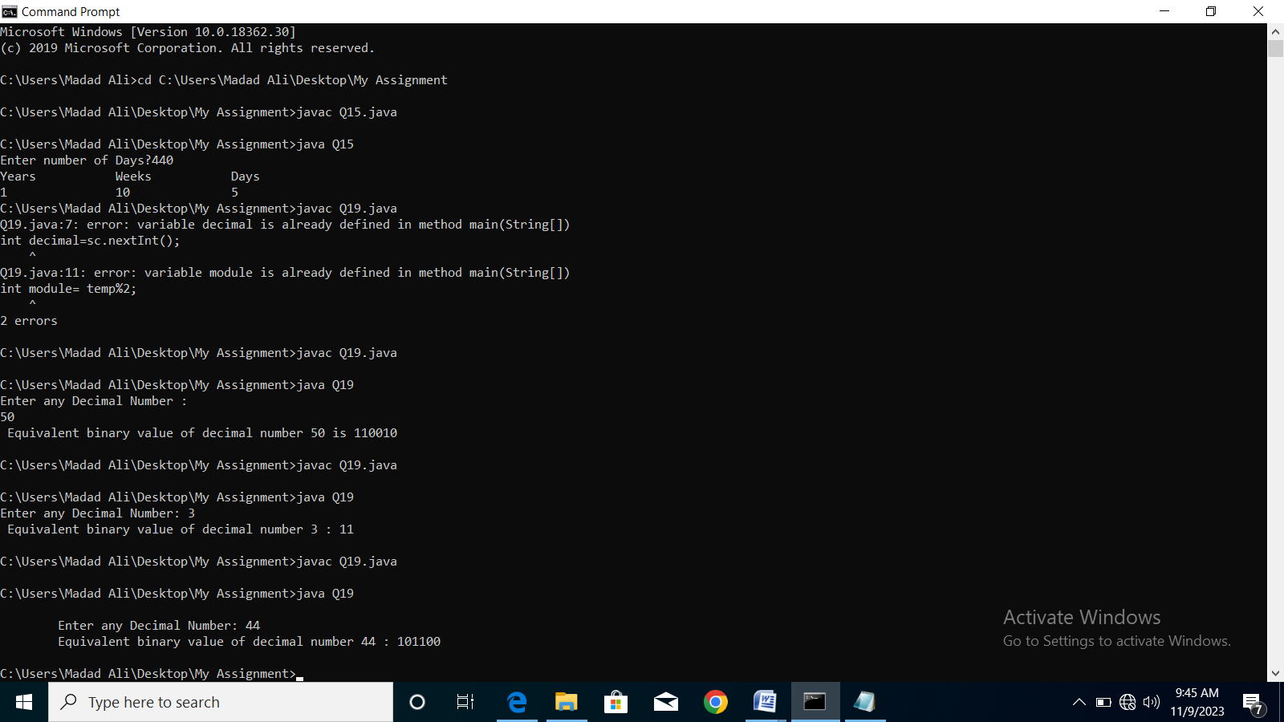import java.util.Scanner;

class Q19 {

public static void main(String[] args) {

Scanner sc= new Scanner(System.in);

int decimal,temp,module;

System.out.print("\n\tEnter any Decimal Number: ");

decimal=sc.nextInt();

String binary="";

temp=decimal;

while (temp>0) {

module= temp%2;

temp=temp/2;

binary=module+binary;

}

System.out.println("\tEquivalent binary value of decimal number "+decimal+" : "+binary );

}

}

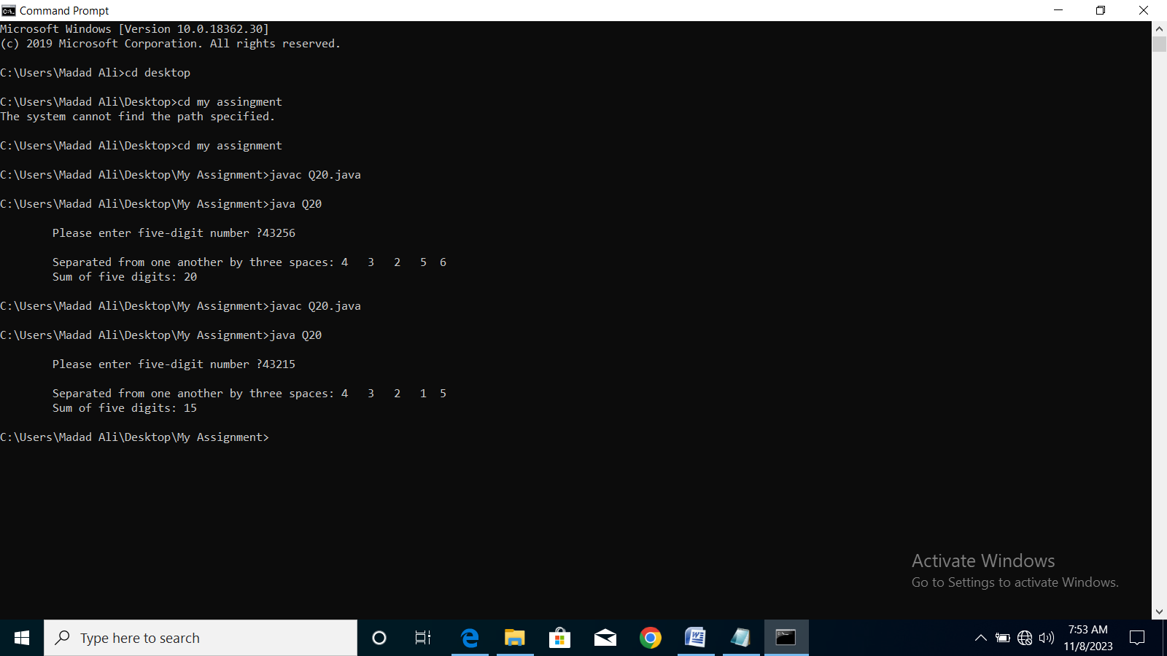**Q.No.20. Write a program that inputs one five-digit number, separates the number into its individual digits and prints the digits separated from one another by three spaces and also print sum of five-digits? Ans: Output:**

import java.util.Scanner;

class Q20 {

public static void main(String args [])

{

int number,number1,number2,number3,number4,number5,sum;

Scanner input= new Scanner(System.in);

System.out.print("\n\tPlease enter five-digit number ?");

number= input.nextInt();

number1= number%10;

number=number/10;

number2= number%10;

number= number/10;

number3= number%10;

number= number/10;

number4= number%10;

number= number/10;

number5= number%10;

sum=number1+number2+number3+number4+number5;

System.out.println("\n\tSeparated from one another by three spaces: "+number5+" "+number4+" "+number3+" "+number2+" "+number1);

System.out.println("\tSum of five digits: "+sum);

}

}

**Q.No.21. Write a program to print ASCII value of all characters.**

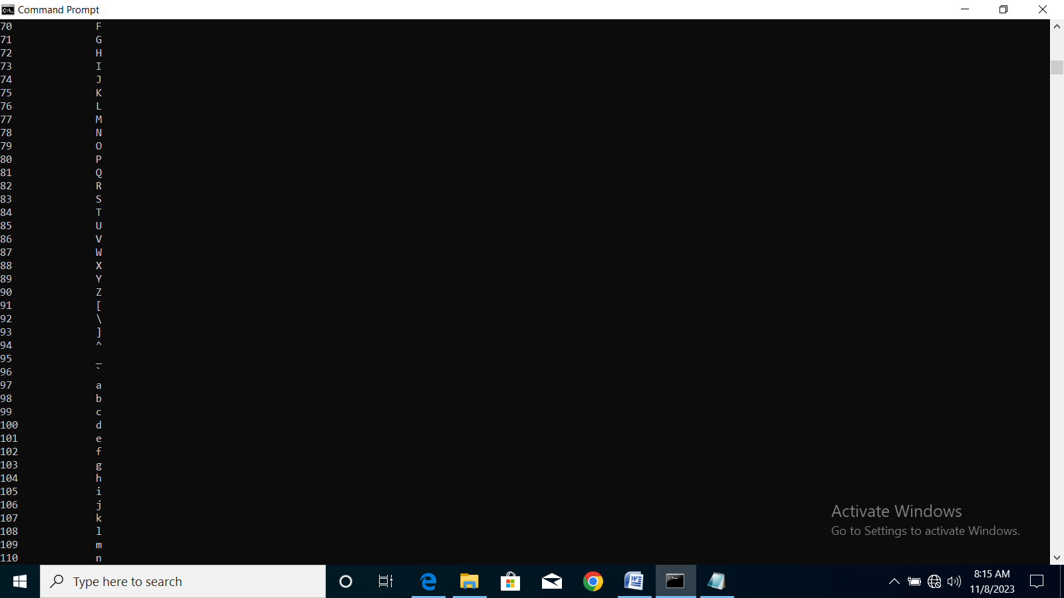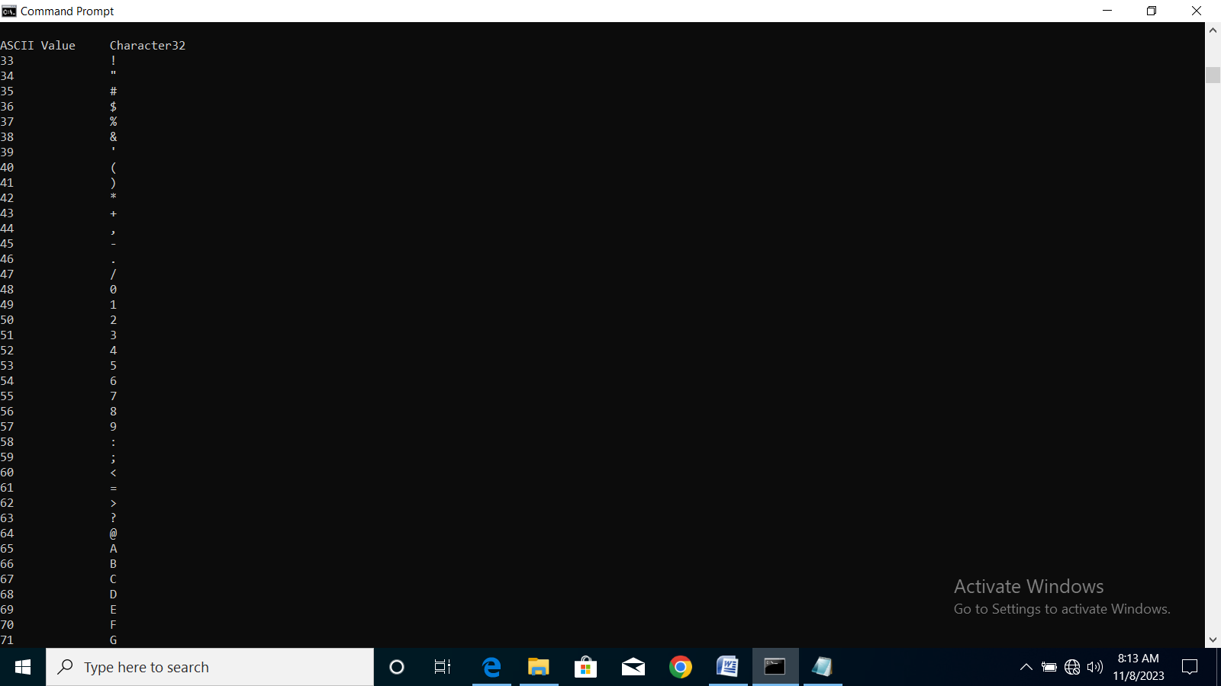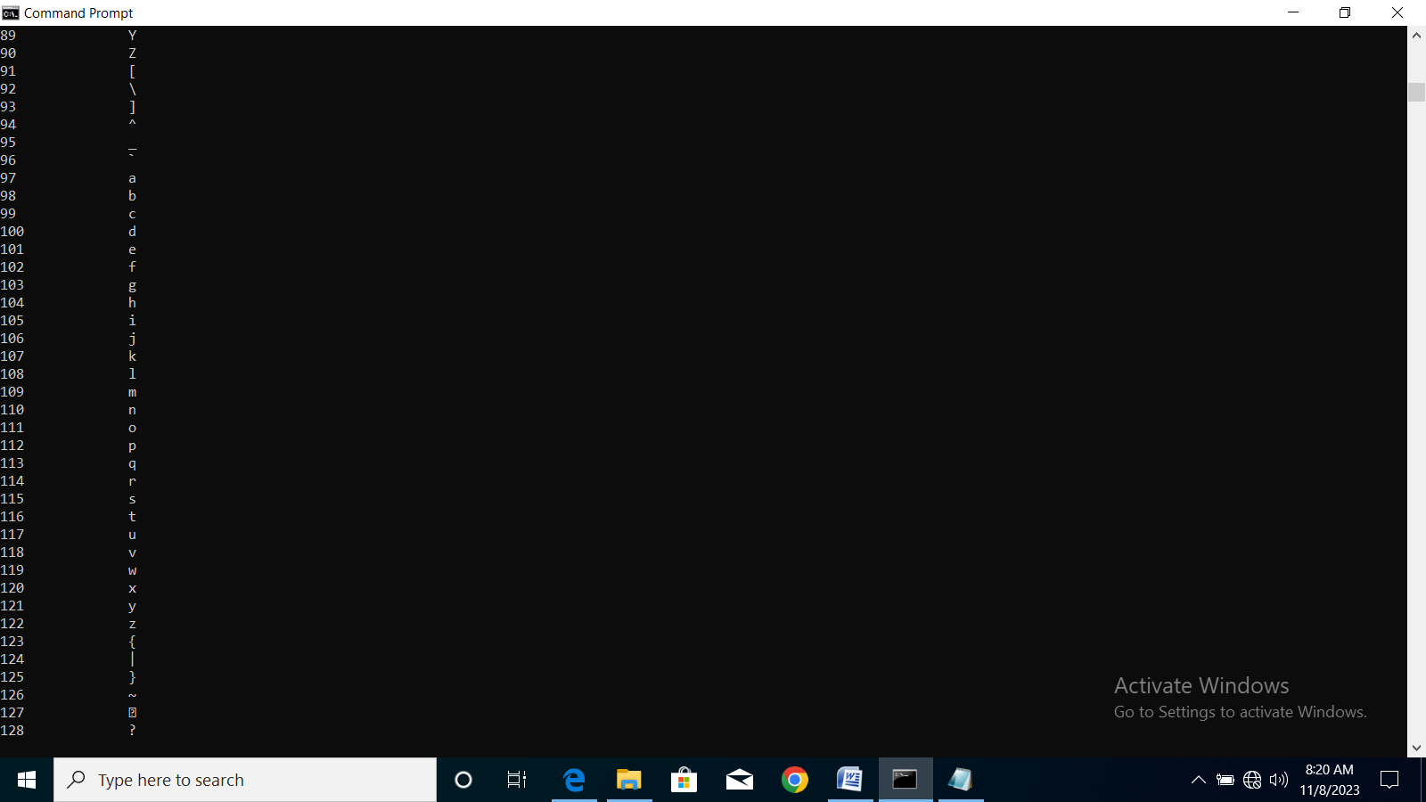**Ans: Output:**

class Q21 {

public static void main(String args[])

{

char ch;

int value;

System.out.print("\nASCII Value\tCharacter");

for(value=32;value<=128;value++) {

System.out.print(value);

ch=(char)value;

System.out.print("\t\t"+ch+"\n");

}

}

}

**Q.No.22. Write a program to reverse any number.**

**Ans: Output:**

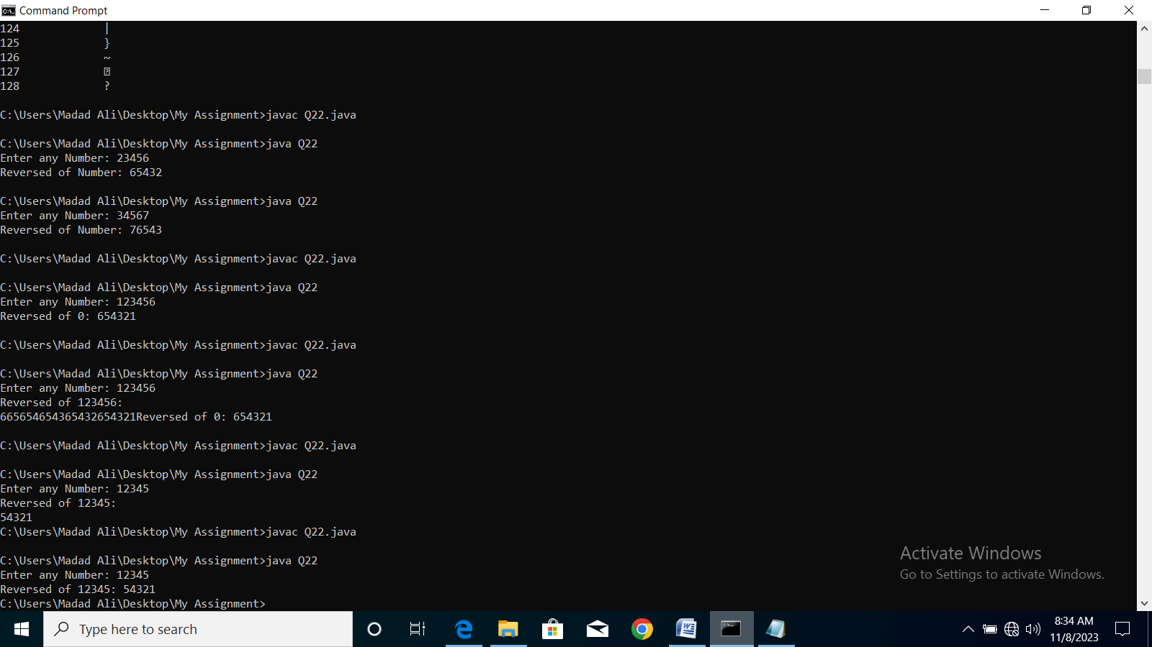import java.util.Scanner;

class Q22 {

public static void main(String args[])

{

int num,reversed=0,digit;

Scanner sc=new Scanner(System.in);

System.out.print("Enter any Number: ");

num= sc.nextInt();

System.out.print("Reversed of "+num+"is: ");

for(;num!=0;num/=10) {

digit=num % 10;

reversed=reversed*10+digit;

}

System.out.print(reversed);

}

}

**Q.No.23. Write a program to convert binary number to Hexadecimal number.**

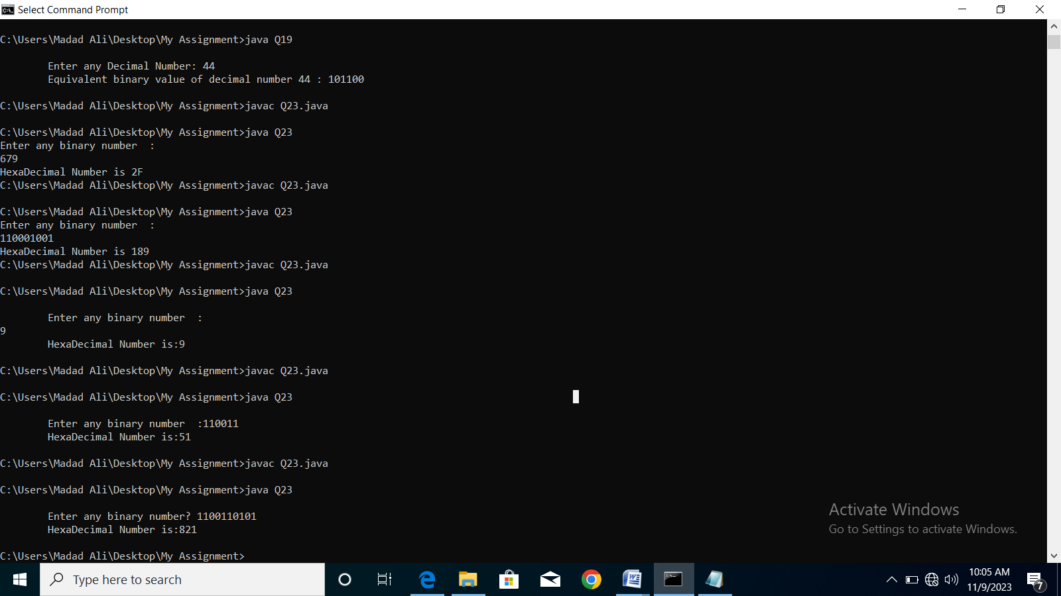**Ans: Output:**

import java.util.Scanner;

class Q23{

public static void main(String[] args) {

Scanner input= new Scanner(System.in);

int hexa=0, base=1;

System.out.print("\n\tEnter any binary number? ");

int binary = input.nextInt();

while (binary>0) {

int reminder = binary % 10;

hexa = hexa + reminder * base;

base = base * 2;

binary = binary / 10;

}

System.out.println("\tHexaDecimal Number is:"+hexa);

}

}

**Q.No.24 Write a program to count the number of words, where a word is defined as any continuous sequence of non-whitespace**

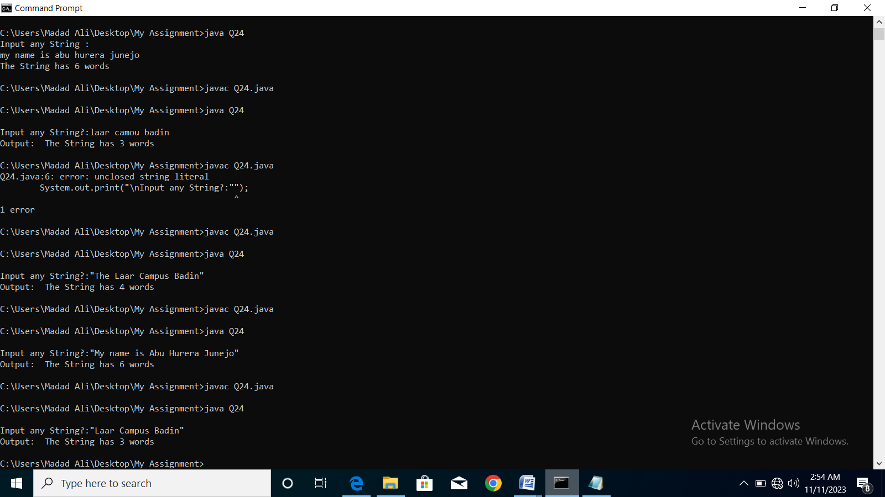**Ans: Output:**

import java.util.Scanner;

class Q24{

public static void main(String[] args) {

Scanner input= new Scanner(System.in);

System.out.print("\nInput any String?:");

String str= input.nextLine();

int count=1;

for (int i=0; i<str.length()-1; i++){

if (str.charAt(i)==' '){

count++;

}

}

System.out.println("Output: The String has " +count+" words");

}

}

**Q.No.25 Write a Java program to add two binary numbers. Input Data:**

**Ans: Output:**

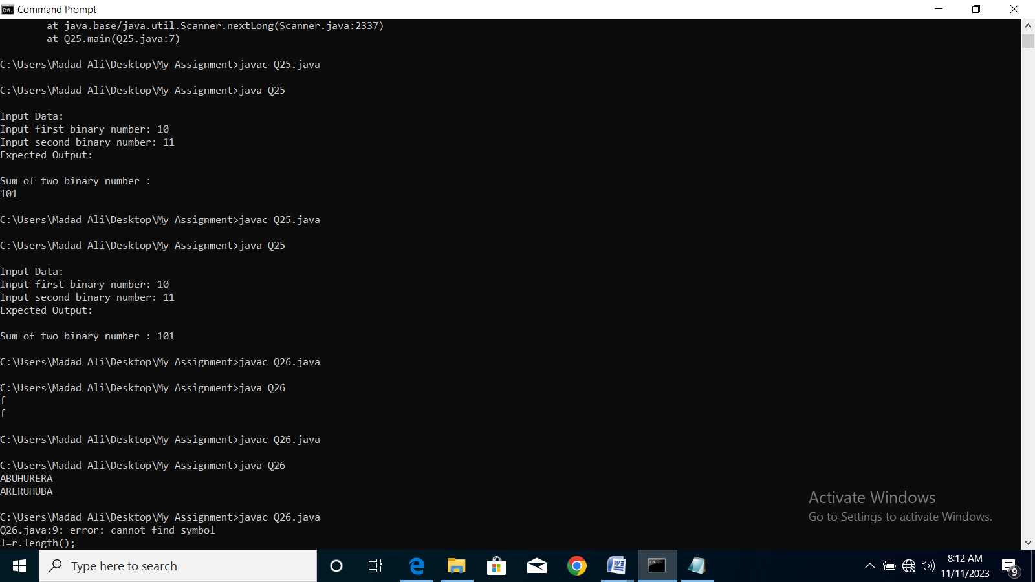import java.util.Scanner;

class Q25{

public static void main(String[] args) {

int i=0, carry=0;

Scanner sc= new Scanner(System.in);

System.out.print("\nInput Data:\nInput first binary number: ");

Long b1= sc.nextLong();

System.out.print("Input second binary number: ");

Long b2= sc.nextLong();

int[] sum= new int[10];

while(b1 !=0 || b2!= 0) {

sum[i++] = (int) ((b1 % 10 + b2 % 10 + carry) % 2);

carry = (int) ((b1 % 10 + b2 % 10 + carry) / 2);

b1 = b1 / 10;

b2 = b2 / 10;

}

if (carry!=0){

sum[i++]= carry;

}

--i;

System.out.print("Expected Output:\n\nSum of two binary numbers : ");

while(i>=0){

System.out.print(sum[i--]);

}

System.out.print("\n");

}

}

**Q.No.26 Write a Java program to reverse your name.**

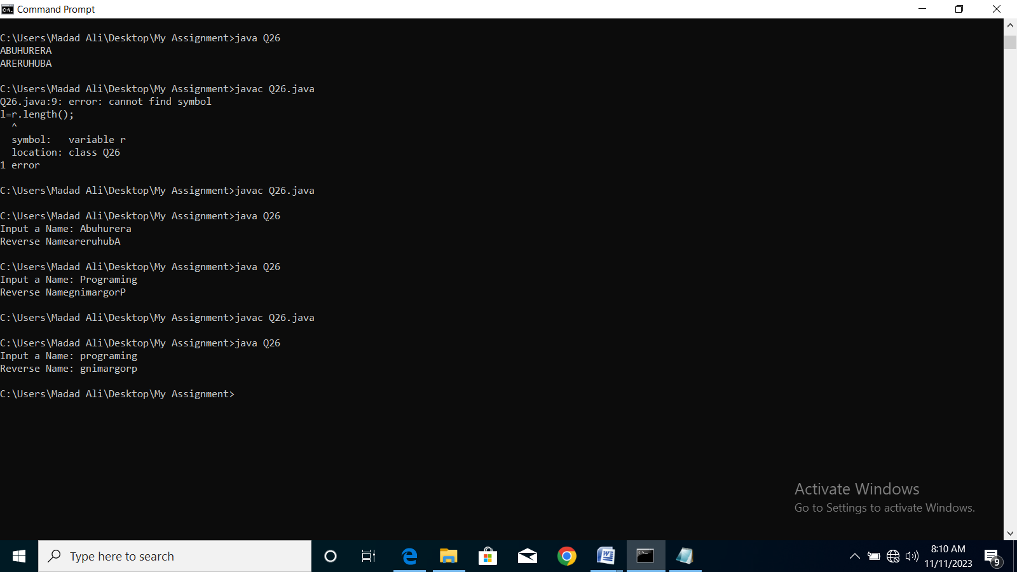**Ans: Output:**

import java.util.Scanner;

class Q26{

public static void main(String[] args) {

int l,i;

String reverse="";

Scanner sc= new Scanner(System.in);

System.out.print("Input a Name: ");

String input= sc.next();

l=input.length();

for (i=l-1; i>=0; i--){

reverse=reverse+input.charAt(i);

}

System.out.println("Reverse Name: "+reverse);

}

}

**Q.No.27 Write a Java program to solve quadratic equations. take your own suppositions**

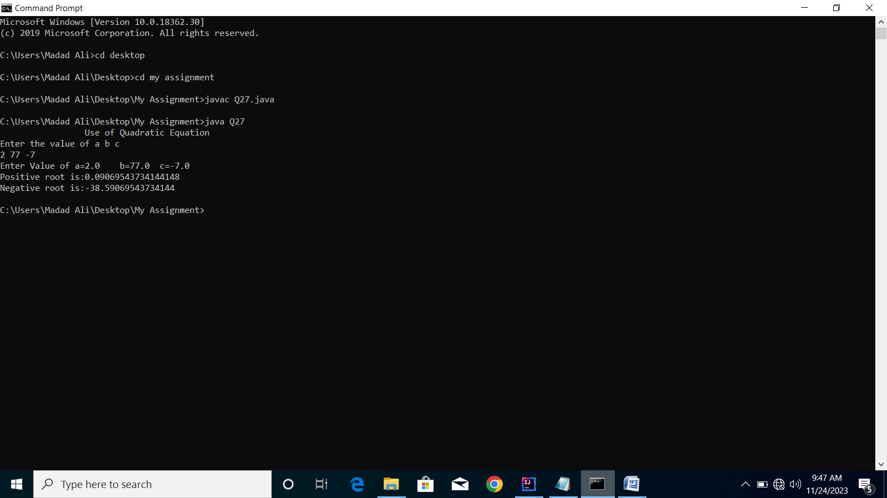**Ans: Output:**

import java.util.Scanner;

public class Q27 {

public static void main(String[] args) {

Scanner input= new Scanner(System.in);

System.out.println("\t\t Use of Quadratic Equation");

double a,b,c;

System.out.println("Enter the value of a b c");

a=input.nextDouble();

b=input.nextDouble();

c=input.nextDouble();

System.out.println("Enter Value of a=" + a + "\tb=" + b + "\tc=" + c);

double discriminant=b*b-4*a*c;

if (discriminant>0) {

double PositiveRoot = (-b + Math.sqrt(discriminant)) / (2 * a);

System.out.println("Positive root is:" + PositiveRoot);

double NegativeRoot = (-b - Math.sqrt(discriminant)) / (2 * a);

System.out.println("Negative root is:" + NegativeRoot);

}

else if (discriminant==0) {

double realRoot = -b / (2 * a);

System.out.println("One real root");

System.out.println("Real root" + realRoot);

}

else

System.out.println("No real roots.Complex root exist");

}

}

**Q.No.28 Write a Java program to get a number from the user and print whether it is positive or negative.**

**Ans: Output:**

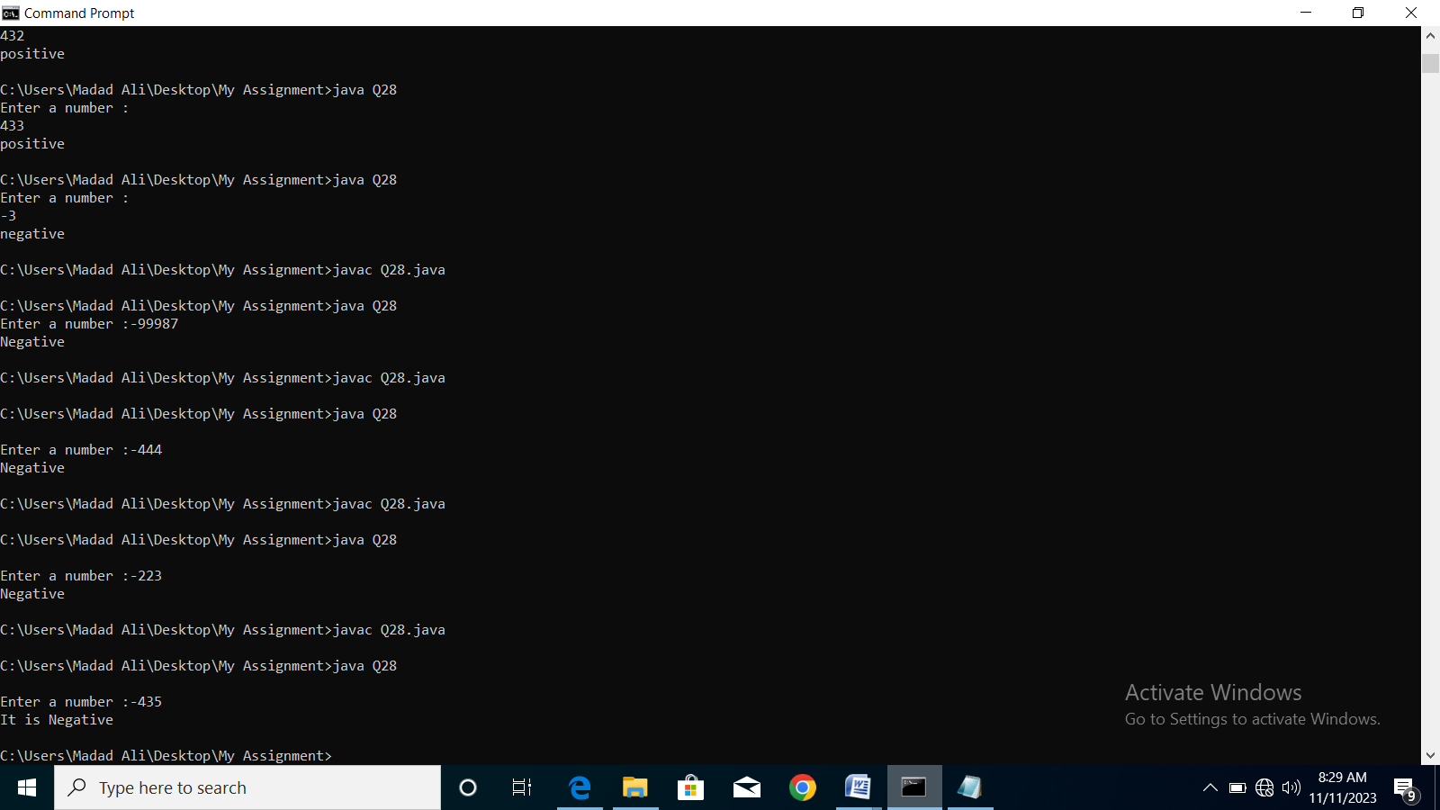import java.util.Scanner;

class Q28{

public static void main(String[] args) {

Scanner input= new Scanner(System.in);

System.out.print("\nEnter a number :");

int num= input.nextInt();

if(num>=0){

System.out.println("It is Positive");

}

else System.out.println("It is Negative");

}

}

**Q.No.29 Write a Java program to find the number of days in a month.**

**Ans: Output:**

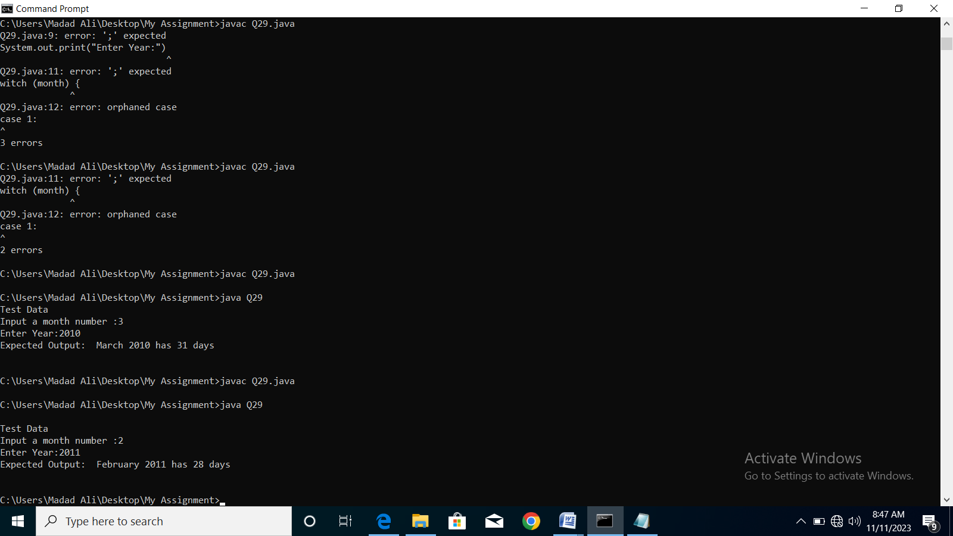import java.util.Scanner;

class Q29{

public static void main(String[] args) {

Scanner input= new Scanner(System.in);

int no_of_days=0;

String month_name="Unknown";

System.out.print("\nTest Data\nInput a month number :");

int month= input.nextInt();

System.out.print("Enter Year:");

int year = input.nextInt();

switch (month) {

case 1:

month_name = "January";

no_of_days = 31;

break;

case 2:

month_name ="February";

if((year%400==0) || ((year%4==0) && (year%100!=0))) {

no_of_days = 29;

}

else

no_of_days= 28;

break;

case 3:

month_name = "March";

no_of_days = 31;

break;

case 4: month_name= "April"; no_of_days=30;

break;

case 5: month_name= "May"; no_of_days=31;

break;

case 6: month_name= "June"; no_of_days=30;

break;

case 7: month_name= "July"; no_of_days=31;

break;

case 8: month_name= "August"; no_of_days=31;

break;

case 9: month_name= "September"; no_of_days=30;

break;

case 10: month_name= "October"; no_of_days=31;

break;

case 11: month_name= "November"; no_of_days=30;

break;

case 12: month_name= "December"; no_of_days=31;

break;

}

System.out.println("Expected Output: "+month_name +" "+ year+" has "+no_of_days+ " days\n");

}

}

**Q.No.30 Write a program in Java to make such a pattern like right angle triangle with number increased by 1.**

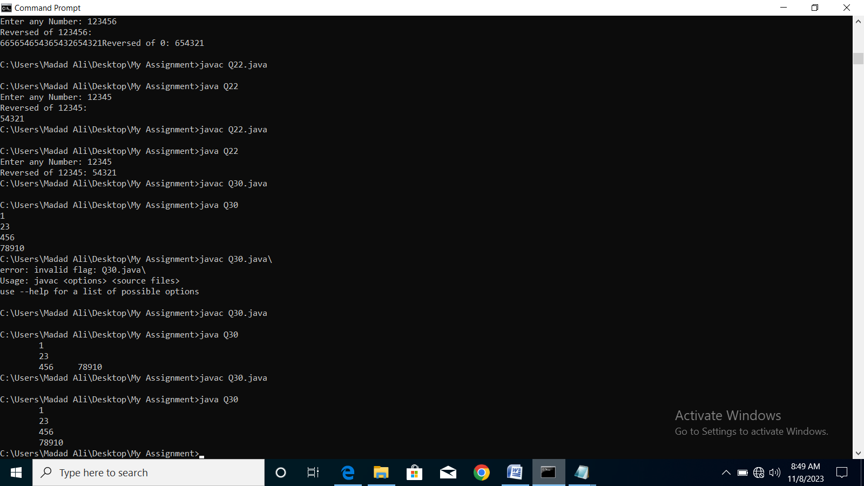**Ans: Output:**

class Q30 {

public static void main(String args[])

{

int i,j,k=1;

for(i=1;i<5;i++){

for(j=1;j<=i;j++)

System.out.print(k++);

System.out.println("");

}

}

}